Table of contents for Systems and Capabilities
Table of contents for Systems and Capabilities 1
  - Standard Operating Procedure - Course Administration 2
    - Trainee Communication and Management of Feedback, Requests, and Appeals 6
    - Pre-course and Post-course Advisory Service 9
    - Administration Systems and Refund of Course Fees 12
  - Standard Operating Procedure - Training Quality 15
    - Content Design and Development 19
    - (a) Establish processes to design content of each course 20
    - (b) Establish processes to develop content of each course 26
    - (c) Consider industry or sector needs in content design and development 29
    - (d) For online and/or blended learning with technology-enabled component, establish processes to deploy a Learning Management System for content delivery 31
    - Trainer Management 32
    - (a) Develop human resource management plan for trainers: 33
    - (b) Establish monitoring process to ensure quality of teaching by trainers 35
    - (c) Take appropriate actions of intervention for trainers, where necessary 36
    - Content Delivery and Monitoring of Teaching and Learning 37
    - (a) Processes to monitor course delivery to ensure learning outcomes are met 38
    - (b) Take appropriate intervention actions for trainees 38
    - (c) For e-learning programmes: use of learning management system, including 39
    - Assessment of Learning 41
    - (a) Ensure assessment principles of reliability, validity and fairness 42
    - (b) Establish processes to review content and/or delivery, including assessment results analysis, stakeholder feedback (e.g. trainees/trainers) 42
    - (c) For assessments that are conducted online, ensure user authentication are carried out 43
  - Standard Operating Procedure - Training Outcomes 45
    - Trainee and Graduate Outcomes 46
    - (a) Track and use performance of Trainees and Graduates to improve 46
    - (b) Improve the quality of customer service 49

Standard Operating Procedure - Course Administration

Area: | 3.1 Course Administration
Created by | Shannah (Project Manager)
Vetted and Reviewed by | Head of Training: Kai Xin Koh
Approved by | Head of Training: Kai Xin Koh
Date of Last Update | 29 April 2024
Version | 1.0

This SOP is to ensure HighSpark’s course administration processes are in accordance with the Skillsfuture guidelines.

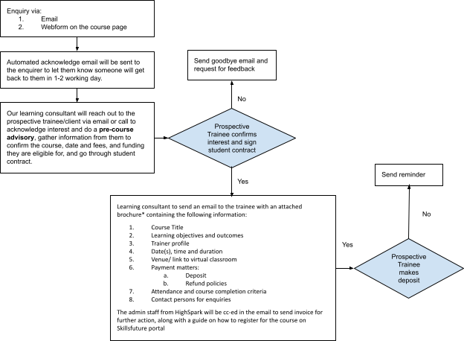
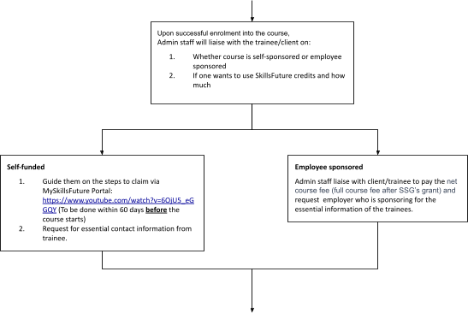

(‘continued)
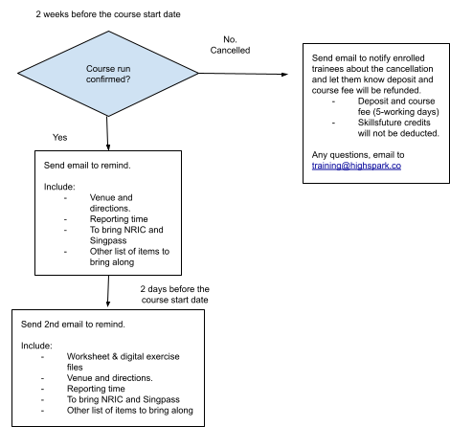



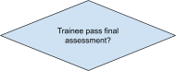



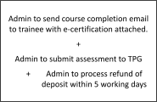

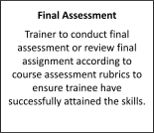
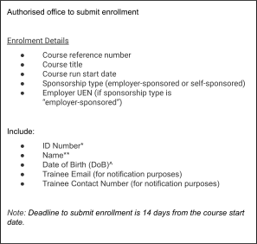
(‘Continued)

Trainee Communication and Management of Feedback, Requests, and Appeals

      - Essential course information:

        - Upon successful enrolment, trainee/client will receive essential course information via email from our project manager. The email will contain the brochure information that they have successfully enrolled to, as well as pre-work or action step(s) that need to be done. Examples:
          - Setting up of account to online course portal (if any)
          - Completing pre-workshop survey: questions to assess their competency and also logistic questions such as dietary preferences (if food is to be catered).
          - Providing past work samples for trainer to establish learner’s baseline,
          - Etc.

        - Brochure information should include:
- Course Title
- Learning objectives and outcomes
- Trainer profile
- Date(s), time and duration
- Venue/ link to virtual classroom
- Payment matters such as deposit and refund policies
- Attendance and course completion criteria
- Contact persons for enquiries

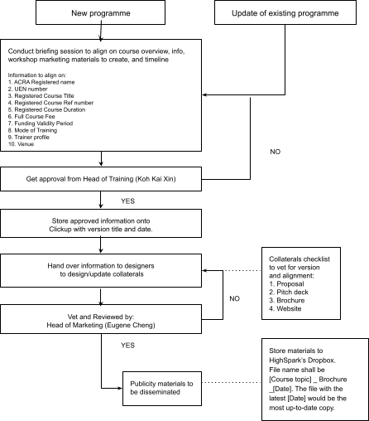

      - *Processes in place to ensure accurate course information is provided to enrolled trainees
        - Learning consultant/support staff shall access the most up-to-date brochure via HighSpark’s organisation Dropbox. File name shall be [Course topic]_Brochure_[Date]. The file with the latest [Date] would be the most
up-to-date copy.
        - Learning consultant/support staff shall ensure the information in the brochure matches that on the website. Should there be any discrepancies, inform Head of Marketing.

      - Provide timely course confirmation to enrolled trainees
        - Automated email will be sent each time an enquiry is received to acknowledge the receipt and to indicate the estimated time HighSpark will get back.
        - Enrolled trainees will be informed about the date which the course will be confirmed (scheduled notification 3 weeks before the course start date).

Establish a closed loop process when communicating with trainee
        - Dedicated person will be in-charge of specific aspects of the process:
- Learning consultant: jannah@highspark.co handles:
  - Course enquiries and recommendations
- Admin: odessa@highspark.co:
  - Process payment matters: invoice, deposit, refunds
  - TPG submissions:
    - Enrolment
    - Attendance
    - Claims
    - Assignments
- Project manager: shan@highspark.co
  - Handles enquiries/requests such as withdrawal, refunds or appeals to redo assignments.
  - Disseminate course information
  - Track Attendance
  - Collate assignments
- For any feedback or requests from trainees, they can fill in a support form or contact us directly via training@highspark.co. They will receive a confirmation email upon submitting the form. Shan will receive the request and reply within 2 working days.

Pre-course and Post-course Advisory Service

Pre-course advisory
- To ensure that the prospective trainee signed up for the course that is suitable to him/her, upon receiving the training enquiry, the learning consultant would conduct a pre-course advisory over a phone call or Zoom meeting. During the call/meeting, the learning consultant would go through:
  - The course content and its relevance to confirm if that is what the prospective trainee is looking for and is of the right fit, i.e. to upskill and reskill them.
  - The grants and subsidies available based on the prospective trainee’s profile, and how the claim process would work.
  - The attendance requirements and assessment that is required to complete the course.
  - The pre-requisite(s) for admission for self-sponsored:
    - English proficient
    - Singaporean/PR
    - Above 25 years old
  - The pre-requisite(s) for admission for SMEs:
    - SMEs that meet all the following eligibility criteria:
      - Registered or incorporated in Singapore
      - Employment size of not more than 200 or with annual sales turnover of not more than $100 million
    - SME-sponsored Trainees:
      - Must be Singapore Citizens or Singapore Permanent Residents.
      - Courses have to be fully paid for by the employer.
      - Trainee is not a full-time national serviceman.

Post-course advisory

- To provide post-course advisory for the graduates, HighSpark would:
  - Send additional free resources for them to consume. This includes guidebooks and bite-sized exercises with sample answers.
  - Leave the trainer’s information and LinkedIn details for them to connect to the trainer, which they can use to seek further support after the course. As our trainer would post bite-sized learnings on LinkedIn, this is a good platform for graduates to learn socially and continuously.
  - Graduates can reach out to training@highspark.co for further support and enquire about other courses that we offer to continue progress. Our learning consultant will advice based on their learning and career goals.

Training for excellent advisory Monitor:
Quarterly reviews will be conducted to ensure consistent quality of advisory support given.
- Review enquiries received and if there are new types of enquiries that require a new set of resources or processes.
- Review time taken to address these enquiries to ensure process is in place to handle them in a timely manner.
- Review feedback submitted by graduates regarding the support and services provided and identify any issues early on and take corrective action as needed.

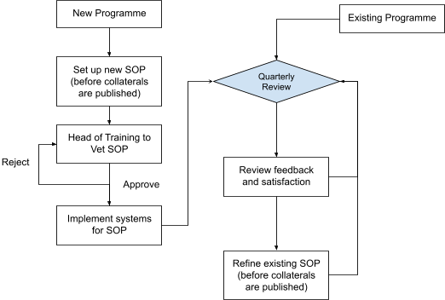

Training:
- Course consellor (or Learning counsultant and relevant stakeholders) will be trained on the SOP for existing and new programmes.
- S/he will also be trained to create new SOP for new programmes in the future.

Administration Systems and Refund of Course Fees

How HighSpark:

Establish administration system to submit assessment results into the Training Partners Gateway including processes for ensuring result accuracy
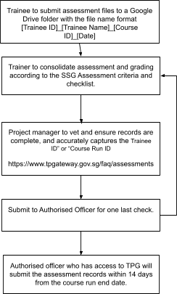

Establish administration system to print and distribute e-certificates or full qualification certificates
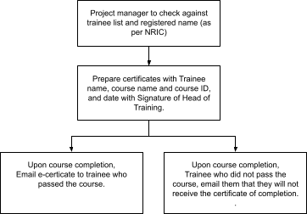

Establish administration system to maintain training and assessment records

Training and assessment records will be stored in Google Drive. Each course will have its own folder containing assessment records, trainee list, feedback form, and attendance records.
Folder will be name [Course name]_[Course ID]_[Date of course].

Establish and communicate refund policy in Trainee Contract
HighSpark refund policy will be published on the course page under FAQs and/or Terms and Conditions. The policy will also be communicated to the prospective trainees by the learning consultant during the pre-course advisory, and reflected in the student contract.

Establish an attendance monitoring system:
For in-person training/workshop, attendance will be captured via:
  - If it is a 1-day session, trainees will be asked to scan a QR code at the start, middle (after lunch break) and end of the session.
  - If the session is half a day, trainees will be asked to scan a QR code at the start and end of the session.
  - These will be recorded in Google sheets with timestamps. And attendance requirement to complete the course is 75% (or based on Skillsfuture’s requirement, whichever is higher).

For virtual training, attendance will be captured via the same means as the in-person training with the added requirements such as:

  - Trainee to turn on their camera throughout the training and for the trainer to record the entire training session in Zoom Gallery view. This would allow us to audit and check if each trainee has been participating in the class.
  - A virtual group photo to be captured at the start, middle and end of the session.
The trainer will also make a deliberate effort to call upon every trainee across the training to answer questions to ensure that they are not away from their keyboard.

For asynchronous training such as online course, attendance will be replaced with course completion rate. At HighSpark, we use www.thinkific.com and www.mightynetwork.com. These platforms come with analytics and dashboard which allows us to track:
  - Number of times the trainee signed in
  - Engagement
  - Completion rate

Standard Operating Procedure - Training Quality

Area | Course Design & Development
Created by | Trainer
Vetted and Reviewed by | Head of Training: Kai Xin Koh
Approved by | Head of Training: Kai Xin Koh
Date of Last Update | 29 April 2024

This SOP is to ensure HighSpark’s has the processes to design and develop course content.

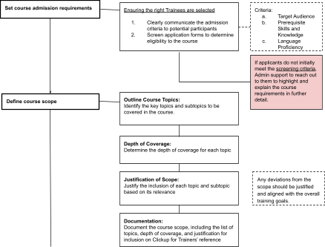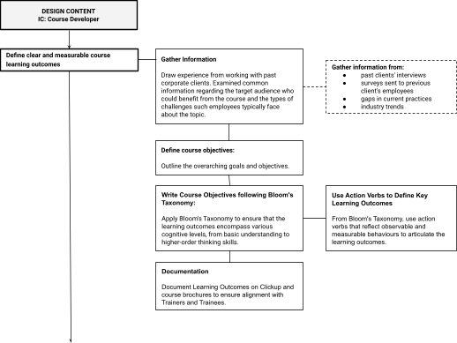

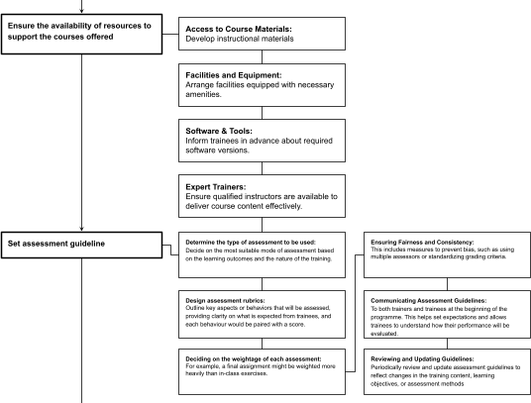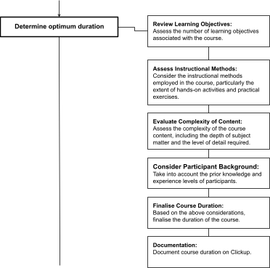

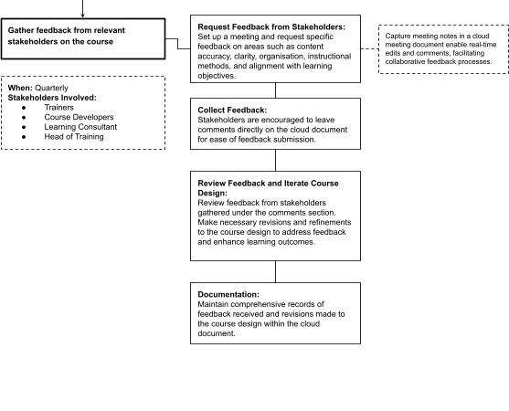

Content Design and Development

Area | 3.2 Training Quality
Created by | Trainer
Vetted and Reviewed by | Head of Training: Kai Xin Koh
Approved by | Head of Training: Kai Xin Koh
Date of Last Update | 29 April 2024

This SOP is to ensure HighSpark’s has the processes to design and develop course content.

(a) Establish processes to design content of each course
      - Define clear and measurable course learning outcomes

Gather Information
          - Draw experience from working with past corporate clients. Examined common information regarding the target audience who could benefit from the course and the types of challenges such employees typically face about the topic.
          - Gather information on:
            - past clients' Needs Analysis interviews
            - surveys sent to previous client's employees
            - gaps in current practices
            - industry trends
            - competencies in Skillsframework

Define Course Objectives:
          - Outline the overarching goals and objectives. These objectives served as the foundation for defining specific learning outcomes that would enable trainees to effectively achieve the course goals.

Write Course Objectives following Bloom's Taxonomy:
          - To ensure that the learning outcomes encompass various cognitive levels, from basic understanding to higher-order thinking skills.

Use Action Verbs to Define Key Learning Outcomes
- From Bloom's Taxonomy, use action verbs that reflect observable and measurable behaviours to articulate the learning outcomes.
For example, the use of verbs like "Tailor," "Structure," "Present," and "synthesise" in the following learning outcomes for a course on Data Storytelling.
  - Tailor your data presentation to your audience
  - Structure your key insights into a compelling narrative
  - Present your slides in an engaging manner

Documentation
          - Document the determined learning outcomes on Clickup and course brochures to ensure Trainers and Trainees are aware of the learning outcomes.

      - Set course admission requirements
        - To ensure that the right profile of trainees are sign up and are well-informed:
          - HighSpark will clearly communicate the admission criteria to prospective trainees through our website, course brochures, marketing materials, and registration forms.
          - Screen applications to ensure that the prospective trainees meet the requirements for enrollment in the course to determine the applicant's eligibility and readiness for the course.
          - If applicants do not initially meet the screening criteria, reach out to them to highlight and explain the course requirements in further detail. If applicants demonstrate a clear understanding of the course expectations and express

confidence in their ability to benefit from the course, consider their eligibility for enrollment.
        - Criteria:

Target Audience:
            - Identify professionals suitable for the nature of the content. For example, if the course is on data, it will best suit professionals such as researchers, analysts, finance executives, and managers who are involved in data analysis and decision-making processes within their organisations.

Prerequisite Skills and Knowledge:
            - Assess the prerequisite skills and knowledge necessary for trainees to derive maximum benefit from the course.
              - For example, a course on data would require trainees who ideally have a foundational understanding of data analysis concepts and familiarity with spreadsheet software like Excel.

Language Proficiency
            - Since the course is conducted in English, trainees are required to have a proficient level of English language skills to understand and engage with the course content, materials, and discussions effectively.

      - Define course scope

Outline Course Topics:
          - Based on the learning outcomes, identify the key topics and subtopics to be covered in the course. Ensure that each topic directly contributes to achieving the desired learning outcomes.

Depth of Coverage:
          - Determine the depth of coverage for each topic, considering the complexity and importance of the content. Allocate sufficient time and resources to cover essential concepts comprehensively.

Justification of Scope:
          - Justify the inclusion of each topic and subtopic based on its relevance to the learning objectives. Any deviations from the scope should be justified and aligned with the overall training goals.

Documentation:
          - Document the course scope, including the list of topics, depth of coverage, and justification for inclusion on Clickup. Ensure Trainers are aware of the course scope.

      - Ensure the availability of resources to support the courses offered

Access to Course Materials:
          - Develop instructional materials such as worksheets, frameworks, case studies, examples, and additional exercises to support course content.
          - Ensure materials are designed to enhance understanding and reinforce key concepts.

Facilities and Equipment:
          - Arrange facilities equipped with necessary amenities like seating arrangements, presentation equipment, whiteboards or flip charts, and internet connectivity.
          - Ensure the physical environment is conducive to learning and supports active participation.

Software & Tools:
          - Inform trainees in advance about required software versions (e.g., Excel, PowerPoint) for the course.
          - Provide guidance on freely available tools for trainees if needed.

Expert Trainers:
          - Ensure qualified instructors are available to deliver course content effectively.
          - Provide guidance and support to trainees as needed.
          - Support staff may also be available to address technical issues and assist with logistical arrangements.

      - Set assessment guideline
        - HighSpark uses a structured approach to ensure that assessments effectively measure the trainees' understanding and mastery of the content:

Determining the type of assessment to be used:
The trainer and/or course developer would decide on the most suitable mode of assessment based on the learning outcomes and the nature of the training. This could include presentations, case studies, simulations, or a combination of these.

Designing of assessment rubrics:
As the courses HighSpark provides are communication courses, there are no “right” answers to the assessments. Therefore, assessments rubrics are created based on the Learning Outcomes of the course. The rubric will outline key aspects or behaviors that will be assessed, providing clarity on what is expected from trainees, and each behaviour would be paired with a score.

Deciding on the weightage of each assessment:
HighSpark would assign weight to each assessment based on their relative importance in determining the overall achievement of the Learning Outcomes. For example, a final assignment might be weighted more heavily than in-class exercises.

Ensuring Fairness and Consistency:
The Assessment guidelines are designed to ensure fairness and consistency in evaluation. This includes measures to prevent bias, such as using multiple assessors or standardizing grading criteria.

Communicating Assessment Guidelines:
The assessment guidelines are clearly communicated to both trainers and trainees at the beginning of the programme. This helps set expectations and allows trainees to understand how their performance will be evaluated.

Reviewing and Updating Guidelines:
Assessment guidelines are periodically reviewed and updated to reflect changes in the training content, learning objectives, or assessment methods. This ensures that assessments remain relevant and effective over time.

      - Determine optimum duration

Review Learning Objectives:
          - Assess the number of learning objectives associated with the course.
          - For courses with approximately 4-6 learning objectives, allocate 1 or 2 days for course duration.
          - Ensure that the allocated time allows for comprehensive coverage of key concepts and skills while facilitating the achievement of desired learning outcomes.

Assess Instructional Methods:
          - Consider the instructional methods employed in the course, particularly the extent of hands-on activities and practical exercises.
          - Courses emphasising hands-on activities, such as creating a presentation deck as a final output, may require additional time for trainees to complete final outputs.
          - Allocate sufficient time for trainees to engage in practical exercises and apply learned concepts effectively.

Evaluate Complexity of Content:
          - Assess the complexity of the course content, including the depth of subject matter and the level of detail required.
          - Highly complex content may necessitate more time for explanation, examples, and addressing trainee queries and challenges.
          - Allocate additional time to ensure trainees have a thorough understanding of the material and can apply it proficiently.

Consider trainee Background:
          - Take into account the prior knowledge and experience levels of trainees enrolled in the course.
          - For trainees new to the concepts, allocate more time for explanation and clarification.
          - Adjust the course pace accordingly to accommodate trainees with varying levels of expertise, ensuring a comfortable learning experience for all.

Finalise Course Duration:
          - Based on the above considerations, finalise the duration of the course, ensuring alignment with learning objectives, instructional methods, content complexity, and trainee background.

Documentation

          - Document the determined course duration on Clickup and course brochure to ensure clear communication with both the Trainers and Trainee

Gather feedback from relevant stakeholders on the course

Gathering feedback on the course through collaborative tools:

Request Feedback from Stakeholders:
          - Initiate a quarterly review meeting with stakeholders. The stakeholders are Trainers, Course Developers, Learning consultant and the Head of Training.
          - The stakeholders will review both quantitative (post-workshop survey done by trainees) and qualitative data (trainers’ observation).
          - During the meeting, to capture recommendations and suggestions to improve course in a meeting note that is made available to the stakeholders.
          - Utilise cloud document formats to enable real-time edits and comments, facilitating collaborative feedback processes.
          - Request specific feedback on areas such as content accuracy, clarity, organisation, instructional methods, and alignment with learning objectives.

Collect Feedback:
          - Stakeholders are encouraged to leave comments directly on the cloud document for ease of feedback submission.
          - Emphasise the importance of stakeholders providing specific, constructive feedback based on their expertise and role in the course design process.

Review Feedback and Iterate Course Design:
          - Review feedback from stakeholders gathered under the comments section of the cloud document.
          - Identify common themes, actionable insights, and areas for improvement based on stakeholder feedback.
          - Make necessary revisions and refinements to the course design to address feedback and enhance learning outcomes.

Documentation:
          - Maintain comprehensive records of feedback received and revisions made to the course design within the cloud document.
          - Document the rationale behind revisions and decisions made during the course design process to provide transparency and inform future iterations of the course.

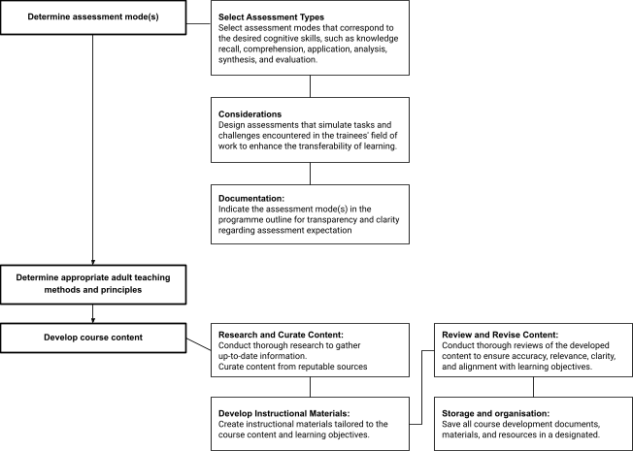
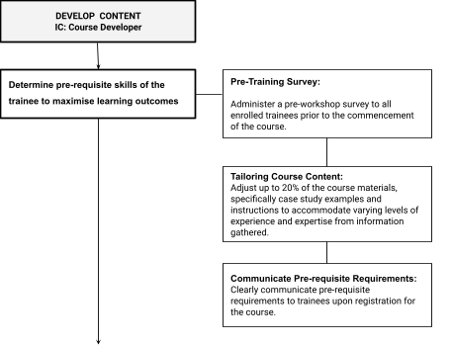

(b) Establish processes to develop content of each course

Determine pre-requisite skills of the trainee to maximise learning outcomes
        - Pre-Training Survey:
          - Administer a pre-workshop survey to all registered trainees prior to the commencement of the course.
          - Include questions to gather additional information about trainees' educational background, work experience, and professional qualifications.
            - Identify relevant certifications, degrees, or prior training indicating proficiency in key subject areas.
          - Include questions designed to assess baseline knowledge, skills, and proficiency levels related to the course topic.
            - Example questions:
              - What is your familiarity with the concepts covered in the course?
              - Rate your proficiency in using relevant software or tools.
              - Have you previously worked on projects involving the application of specific skill sets?
              - What are the common challenges you typically face in related scenarios?
          - Request trainees to self-assess their current abilities and experience in relevant areas of the learning objectives.
        - Tailoring Course Content:
          - Adjust course pace, depth, or focus of the training to accommodate varying levels of experience and expertise from information gathered from the pre-training assessment
            - Allocate less time to topics trainees are advanced in, focusing more on areas requiring deeper exploration or advanced concepts.
            - Incorporate supplementary resources to address any identified gaps in trainees' knowledge or abilities.
        - Communicate Pre-requisite Requirements:
          - Clearly communicate pre-requisite requirements to trainees upon registration for the course.
          - Provide guidance on recommended preparatory activities or resources to enhance their pre-requisite skills before the course begins

Determine assessment mode(s)

Select Assessment Types
          - Refer to Bloom's taxonomy to determine the cognitive levels targeted by the course objectives.
          - Select assessment modes that correspond to the desired cognitive skills, such as knowledge recall, comprehension, application, analysis, synthesis, and evaluation.
          - Common assessment types include:
            - Quizzes or tests for assessing knowledge and comprehension. (formative assessment).
            - Presentations or demonstrations for assessing communication and presentation skills (summative assessment). Only summative assessments will be used as the final assessment to be submitted to the TPG portal.

Considerations
          - Design assessments that simulate tasks and challenges encountered in the trainees' field of work to enhance the transferability of learning.
          - Distribute assessment modes evenly throughout the course to ensure a balanced assessment load for trainees (and avoid assessment fatigue)
          - Ensure that assessments can be effectively administered and evaluated within the constraints of the course delivery method. (select assessment modes that are compatible with the delivery format. e.g., in-person workshops, online courses)
          - Provide examples or samples of assessment tasks to illustrate expectations and standards.

Documentation:
          - Indicate the assessment mode(s) in the programme outline for transparency and clarity regarding assessment expectation

Determine appropriate adult teaching methods and principles (andragogy)
        - Prioritise active learning approaches, such as interactive lectures, group discussions, case studies, and hands-on exercises, to ensure trainees remain engaged and actively involved throughout the workshop.
        - Foster a collaborative learning environment where trainees can engage with peers, share insights, and learn from each other's experiences.
        - Design activities and exercises that simulate real-world challenges or tasks relevant to trainees' professional roles or interests.
        - Offer additional resources, such as readings, online tutorials, or self-assessment tools, for trainees to further enhance their understanding outside of workshop hours.
        - Provide flexibility in workshop delivery, allowing trainees to choose sessions or activities that best align with their interests or learning need

Develop course content

Research and Curate Content:

          - Conduct thorough research to gather up-to-date information, examples, case studies, and best practices relevant to the course topic.
          - Curate content from reputable sources, including academic journals, industry publications, online resources, and expert insights, to enrich the course material.

Develop Instructional Materials:
          - Create instructional materials tailored to the course content and learning objectives, such as slide presentations, handouts and worksheets.
          - Design materials that incorporate diverse instructional strategies, including visual aids, interactive elements, real-world examples, and practical exercises

Review and Revise Content:
          - Conduct thorough reviews of the developed content to ensure accuracy, relevance, clarity, and alignment with learning objectives.
          - Seek feedback from stakeholders (Head of Trainer & Trainers) and identify areas for improvement and make necessary revisions.

Storage and organisation
          - Save all course development documents, materials, and resources in a designated Dropbox folder with clear main and subfolders to facilitate easy navigation and organisation.
          - Standardise file naming system to ensure consistency and clarity across all documents. For example Course Name_Presentation Slides_v1

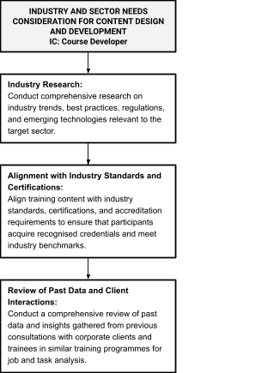

(c) Consider industry or sector needs in content design and development

Industry Research:
        - Conduct comprehensive research on industry trends, best practices, regulations, and emerging technologies relevant to the target sector.
        - Stay updated on industry news, reports, and publications to gain insights into current challenges, opportunities, and evolving skill requirements.

Alignment with Industry Standards and Certifications:
        - Align training content with industry standards, certifications, and accreditation requirements to ensure that trainees acquire recognised credentials and meet industry benchmarks. To check against competencies under the Skillsframework provided by IAL.

Review of Past Data and Client Interactions:
        - Conduct a comprehensive review of past data and insights gathered from previous consultations with corporate clients and trainees in similar training programmes for job and task analysis.
        - Analyse
          - interviews conducted during Needs Analysis sessions with corporate clients
          - pre-workshop surveys

          - and samples of existing outputs like proposals, emails, or other collaterals
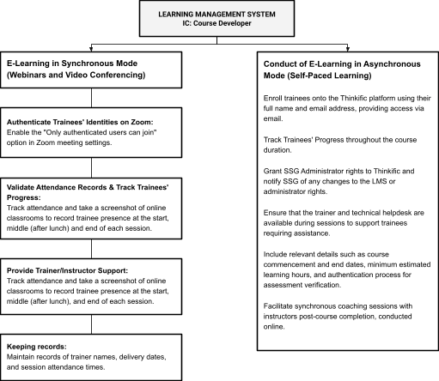

(d) For online and/or blended learning with technology-enabled component, establish processes to deploy a Learning Management System for content delivery

A blended learning approach is ideal for workshops where content comprehension benefits from pre-learning or independent study so that during the live sessions, the emphasis is placed on providing feedback and facilitating discussions, rather than providing theoretical knowledge.

Synchronous learning will be chosen when immediate interaction, feedback, and collaboration are crucial for achieving workshop objectives for courses that are more complex and require close guidance and interaction with the trainer.

Blended learning that includes self-paced course (asynchronous)
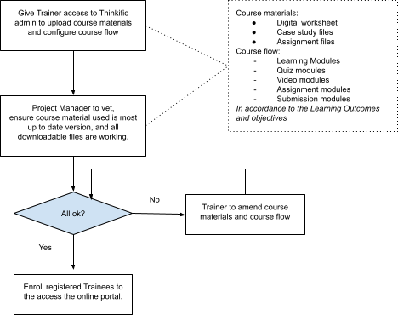

Online learning (Synchronous)
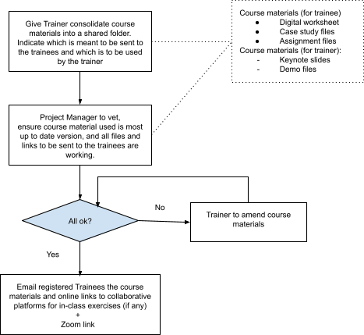

Provide Technical Support during the session
Ensure that technical help is available during sessions to support to address any technical issues encountered by trainees during sessions. Such issues can be: Trouble loading links to collaborative platforms, trouble downloading the files.

Keeping records
        - Maintain records of trainer names, delivery dates, and session attendance times.
        - Retain full recordings of each online session for a minimum of 3 years after course completion

Trainer Management

Area | 3.2 Training Quality
Created by | Learning Consultant
Vetted and Reviewed by | Head of Training: Kai Xin Koh
Approved by | Head of Training: Kai Xin Koh
Date of Last Update | 29 April 2024
Version | 1.0

(a) Develop human resource management plan for trainers:
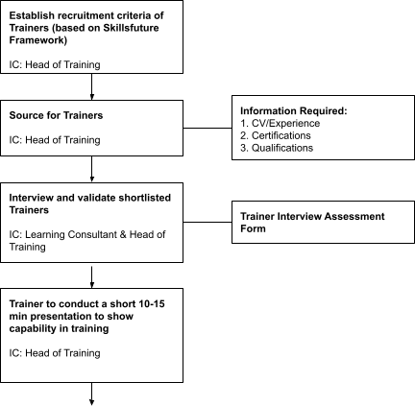
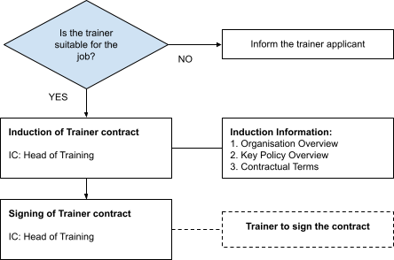

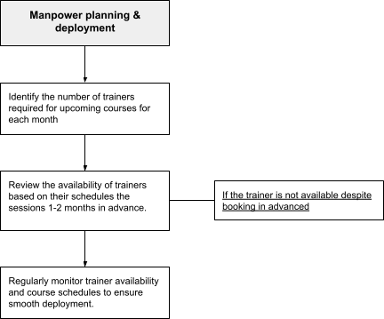

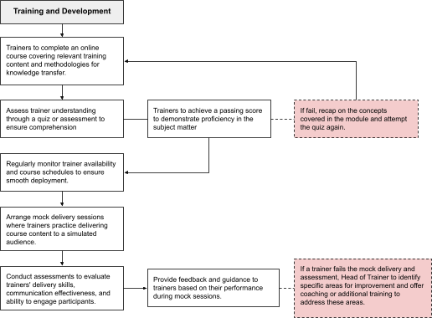

(b) Establish monitoring process to ensure quality of teaching by trainers
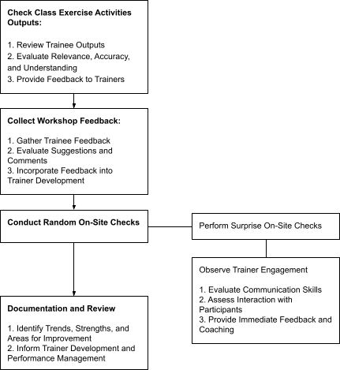

(c) Take appropriate actions of intervention for trainers, where necessary

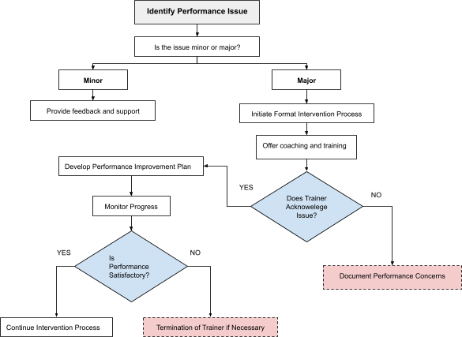

Content Delivery and Monitoring of Teaching and Learning

Area: | 3.2 Training Quality
Created by | Shannah (Project Manager)
Vetted and Reviewed by | Head of Training: Kai Xin Koh
Approved by | Head of Training: Kai Xin Koh
Date of Last Update | 29 April 2024
Version | 1.0

This SOP is to ensure the quality of HighSpark’s course in its trainers.

(a) Establish processes to monitor course delivery to ensure learning outcomes are met

Formative Assessment

- Use various assessment methods such as quizzes, polls, group discussions, and individual exercises throughout the session to assess learning.
- Review formative assessment results to identify trends and areas for improvement in course delivery
- Trainers make real-time adjustments to delivery: course pace, content delivery, and instructional methods based on formative assessment feedback

Summative Assessment

- Conduct a summative assessment at the conclusion of the course to evaluate trainees' overall achievement of learning outcomes. For example: Craft presentation deck that aligns with principles taught in class
- Evaluate and analyse summative assessment results to determine the extent to which learning outcomes have been met

(b) Take appropriate intervention actions for trainees
- Formative Assessment: If Trainers observe that trainees are struggling, Trainer to
  - Provide immediate feedback and support to trainees.
  - Offer in-depth, explanations, or practice opportunities.
  - Encourage peer collaboration and support.

- Summative Assessment: If Trainers observe that trainees are struggling, Trainer to
  - Provide feedback/coaching to trainees to help bridge the learning gaps (note: without giving answers to them)
  - Invite trainees to revisit course materials
  - Share additional resources to trainees
  - Invite trainees to attempt the assessment again.

(c) For e-learning programmes: use of learning management system, including
      - User authentication:
A few ways HighSpark can verify the identity of users/trainees to maintain the integrity of the course and ensure that only legitimate trainees are interacting with the materials, submitting assignments, and engaging in discussions. This reduces the likelihood of cheating, plagiarism, or impersonation, preserving the credibility and validity of the learning experience.

- E-Learning in Synchronous Mode (Webinars and Video Conferencing)
  - Authenticate Trainees' Identities on Zoom:
    - Enable the "Only authenticated users can join" option in Zoom meeting settings.
    - Only users logged into Zoom with authorised emails can access the meeting.
  - Validate Attendance Records & Track Trainees' Progress:
    - Track attendance and take a screenshot of online classrooms to record trainee presence at the start and end of each session.
  - Trainees must keep their video cameras turned on throughout the session for recording purposes.
- Self-paced online course (Thinkific)
  - HighSpark will enroll trainees onto the Thinkific platform using their full name (as per SingPass or NRIC) and email address, providing access via email.
  - They will receive an email that prompts them to access the account with the unique password that is generated by the system.
  - Include relevant details such as course commencement and end dates, minimum estimated learning hours, and authentication process for assessment verification.
  - HighSpark will also Grant SSG Administrator rights to Thinkific and notify SSG of any changes to the LMS or administrator rights

Monitoring of delivery of lesson according to lesson objectives

- Thinkific platform has the analytics function for us to track the engagement for each course module, track trainees’ progress and activity. An automated notifications will be sent to check in with learners/ remind on the completion date. If engagement and progression rate is low,
  - HighSpark will follow up with the trainee individually to check-in.
- There will be bite-sized quiz after each module to test the trainees’ understanding of the new concept or learning. Should there be a high fail rate,

  - it might indicate a need to refine the course delivery and materials in order to foster better understanding about the topic amongst the trainees.
  - Trainer will provide immediate support or guidance through a coaching session to ensure that learning outcomes are met.
- Regularly review learner engagement and activity analytics provided by the LMS.
- Identify trends or patterns indicating areas of difficult and adjust course materials or provide additional resources

Assessment of Learning

Area: | 3.2 Training Quality
Created by | Trainer, Razinah
Vetted and Reviewed by | Head of Training: Kai Xin Koh
Approved by | Head of Training: Kai Xin Koh
Date of Last Update | 29 April 2024
Version | 1.0

(a) Ensure assessment principles of reliability, validity and fairness

Reliable

- Develop clear and specific evaluation criteria that align with the learning objectives and assess relevant skills and competencies.
- Provide assessors with detailed scoring rubrics or assessment guidelines.

Valid

- Ensure that assessment criteria and tasks are aligned with course objectives.
- Review assessment content and tasks with subject-matter experts to confirm validity.

Fair

- Provide assessors with detailed scoring rubrics or assessment guidelines.
- Avoid bias in assessment by evaluating all presentations against the same criteria.
- Provide equal opportunities for all trainees to demonstrate their skills and knowledge.
- Allow trainees to appeal assessment decisions if they believe there has been an error or unfairness.

(b) Establish processes to review content and/or delivery, including assessment results analysis, stakeholder feedback (e.g. trainees/trainers)

Gather data

- Evaluate individual trainee performance and overall performance across assessments.
- Evaluate feedback forms to gather comprehensive feedback from various stakeholders, including trainees and trainers.
- Identify patterns in areas of weakness or difficulty to pinpoint gaps in understanding or delivery.

Content and Delivery Review:

- Ensure alignment between assessment outcomes and intended learning objectives.
- Assess the effectiveness of instructional materials and activities, based on assessment results and stakeholder feedback.

Update Course Materials, Content and Delivery
- Identify and update course elements requiring revision, such as presentations, handouts, activities, and assessments, to address identified areas for improvement.
- Clarify confusing concepts, rectify errors, and integrate new information or best practices.
- Enhance delivery methods to boost engagement, interactivity, and instructional effectiveness.

Quality Assurance and Validation:

- Validate changes and improvements with the Head of Trainer
- Head of Trainer conduct quality assurance checks on revised materials to ensure accuracy, relevance, and coherence.

Communicate Updates

- Communicate updates and revisions to trainers to keep them informed and aligned with course changes.
- Update course brochures to reflect any major changes in learning outcomes for future trainees.
- Reflect the file version on the file name to ensure trainers are utilizing the correct version of materials.

(c) For assessments that are conducted online, ensure user authentication are carried out

To ensure that trainees are the ones who completed and submitted the assignment,

- For assignment submission via Thinkific or Email

HighSpark would be able to track the properties of the file submitted to check for any suspicious areas. Example: The ‘last saved by’ should be the name of the trainee. And the number of revisions and editing time should look reasonable. Here’s a screenshot as an example:
- Assessment in recording format:
  - HighSpark would also require the trainee to record their thought process of what learnings they have applied to the assignment, how they tackled it, and to present the final presentation. This would allow the trainer to assess if it was indeed the trainee who completed the course content and assignment. OR
  - The trainer will conduct a 30-minute phone call with each participant once all trainers have submitted the assessment

    - At the start of the call, the trainer will verify the trainee by having them provide:
      - Full name as per NRIC
      - NRIC number
      - Date of birth
      - Company name [if sponsored by employer]
    - During this call, trainer will engage in a detailed discussion about the assignment, asking questions to assess trainees’ understanding of the content and their thought process in completing the task.
    - Trainees are required to provide explanations or insights into specific aspects of their work to verify their authorship.
    - This interactive approach allows us to authenticate the assignment while also providing an opportunity for trainees to demonstrate their knowledge and understanding of the material.

Standard Operating Procedure - Training Outcomes

Area: | 3.3 Training Outcomes
Created by | Learning Consultant: Jannah
Vetted and Reviewed by | Head of Training: Kai Xin Koh
Approved by | Head of Training: Kai Xin Koh
Date of Last Update | 29 April 2024
Version | 1.0

This SOP is to ensure HighSpark has processes to track trainee/ graduate outcomes.

Trainee and Graduate Outcomes

(a) Track and use performance of Trainees and Graduates to improve

      - Improving Quality of Trainer and Course Content

        - Track: Gather feedback from trainees on the Trainer's performance and overall engagement with the course materials.
        - Who: Learning Consultant
        - Mode: Post-training surveys/ Quality of assessment submission
        - When: Immediately after the workshop

Examples of Feedback Questions:
          - Did the course content align with your expectations and learning needs?
          - Were the learning objectives clearly defined and achieved throughout the course?
          - Did the trainer demonstrate expertise and proficiency in the subject matter?
          - Do you have any suggestions for improving the course content or materials?
        - Condition: If the satisfaction score for either the course content or the trainer falls below 70%, a review will be conducted to identify areas for improvement and implement necessary corrective actions

Action Plans:
          - Use feedback to identify strengths and areas for improvement in trainer effectiveness and course content relevance, such as clarity of instructions and relevance of materials.
          - Incorporate feedback into course content updates or revisions to address trainee needs and enhance learning outcomes.

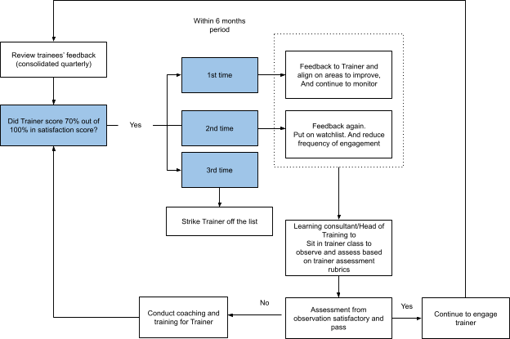

      - Improving Quality of Course Delivery:

        - Track: Gather feedback from trainees on the effectiveness of course delivery. This includes factors such as trainer effectiveness, communication skills, engagement levels and instructional methods
        - Who: Learning Consultant
        - Mode: Post-training surveys
        - When: Immediately after the workshop

Examples of Feedback Questions:
          - How engaging and interactive were the training sessions?
          - Did the trainer effectively communicate the course content?
          - Were concepts explained clearly and understandably?
          - Did the trainer encourage participation and facilitate discussions effectively?
          - Do you have any feedback on the pacing or organization of the training sessions?

        - Condition: If the satisfaction score for the course delivery falls below 70%, a review will be conducted to identify areas for improvement and implement necessary corrective actions

Action Plans:
          - Identify areas for improvement in trainer delivery techniques and session organisation.
          - Provide trainer coaching or development opportunities to enhance delivery effectiveness.

      - Evaluating Course Outcomes:
        - Track: Gather data on trainee progress and performance post-training, including job scope expansion and job performance improvements.
        - Who: Learning Consultant
        - Mode: Survey/ Follow-up Email
        - When: 3 months after the workshop

Examples of questions to ask:
          - How has the training impacted your job responsibilities or duties?
          - Have you been able to apply what you learned in the training to your work tasks?
          - Have you noticed any improvements in your job performance since completing the training?
          - Can you provide examples of how you have applied the knowledge or skills gained from the training in your work projects or tasks?
          - How do you feel the training has contributed to your professional development or career advancement?

Action Plans:
          - Make adjustments to the curriculum, instructional methods, and support services to better align with the desired outcomes and ensure that trainees are equipped with the knowledge and skills they need for success.
          - Highlight successful outcomes in course brochures to inform future trainees about potential benefits.

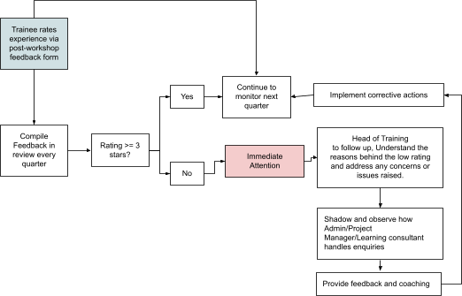

(b) Improve the quality of customer service

Post Workshop
      - Upon completion of their engagement with HighSpark, each trainee will receive an email prompting them to rate their overall experience with HighSpark via a post-workshop survey
      - Trainees are encouraged to provide honest feedback, as it serves as a valuable metric for assessing customer satisfaction.
      - Any feedback received below a 3-star rating will trigger immediate attention and follow-up from the Head of Training or supervisor of the officer, who will then promptly address any concerns or issues raised by trainees to ensure their satisfaction.

Every Quarter
      - Every quarter, our team will conduct a comprehensive review of the average star ratings received from trainees and prospective trainees.
      - Any deviations from our target rating will be thoroughly investigated, and corrective actions will be devised and implemented as necessary.

